Contact: Bob O’Donnell
TECHnalysis Research, LLC
Phone (650) 224-2355
bob@technalysisresearch.com

Press Release

New Study Shows Tech Influence on New Car Purchases Modest Among Consumers

Safety Features at Top of Tech Wish Lists for New Cars; Tech Branded Cars Have Potential
Foster City, CA –September 6, 2016: The world of smart, connected, electric/hybrid and autonomous cars is growing at a phenomenal rate. Consumer interest in the technology enabling those changes is also growing, but not as fast as market hype would indicate. In fact, according to a new study released by TECHnalysis Research not a single tech-related feature was considered more important than traditional car metrics like looks, mileage, performance and car type.
The results are based on a recently completed survey of 1,000 US consumers who own a car and plan to purchase another within 2 years. Survey respondents answered questions about the cars they own, how often they drive, what they’re planning to prioritize for the next purchase, and much more. The survey placed particular focus on consumer’s interest in a number of specific car-technology features, as well as the relative importance of these features and others involving autonomous or assisted driving capabilities.
“Consumers interest in automotive technologies is definitely increasing,” noted TECHnalysis Research President Bob O’Donnell, “but they’re more interested in the safety-focused tech features than the whiz bang-style autopilot features that some car vendors are touting. In fact, many consumers voiced serious concerns about autonomous driving features, citing safety and reliability issues.”
Several of the top tech features represent more incremental improvements, designed to make for a more pleasant in-car experience. Figure 1 shows the rankings (lower is better) that survey respondents gave to popular tech features.
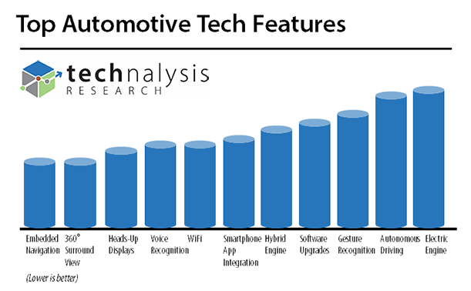
Fig. 1
In addition to tech car features, the study also looked at the use of ridesharing services such as Uber and Lyft and their potential impact (or not) on new car purchase plans. Finally, the study gauged the potential interest that consumers might have if tech brands such as Apple or Google were to produce their own branded cars. Though it was purely hypothetical, the strong interest consumers showed was quite surprising.
“Given what a huge jump it is from smartphones and tablets to cars, I was very surprised to see the level of consideration that consumers said they would give to big tech brands like Google and Apple,” O’Donnell continued. “It appears traditional car vendors really do need to be concerned about the potential impact that these companies could have on the automotive industry.”
A summary version of the Car Technology report is available in PDF format and can be downloaded for free here. The complete 63-slide version of the report with detailed breakdowns for every question is available for purchase. For additional information, please e-mail the author at bob@technalysisresearch.com.
Founded by technology market research veteran Bob O’Donnell, TECHnalysis Research, LLC provides strategic consulting and market research services to the technology industry and professional financial community. Building on a deep understanding of critical technology and business trends, in conjunction with hard-hitting, original research, the firm provides unique "out-of-the-box" perspectives that are still grounded in the practical realities of the technology, media and telecom markets.

